Project Name:
BMP & TGA Image Viewer

Name : Md.Nasim
Student ID : 0905018
Level : 1 Term : 2

This is a simple image viewer software that can be used to view uncompressed 24 –bit BMP image and also 24-bit TGA image .

This software has been developed in C language and a modified version of OpenGl.

How to compile:
This software can be compiled by using Microsoft Visual C++
6.0

Features of the project:
- View the image in perfectly aligned form
- Zoom in as much as one wants and zoom out upto .5X
- View the image in rotated form (both counterclockwise and clockwise)
- Delete a picture
- Scroll left,right,up and down when the image size becomes greater than the active window size

Some screenshots:

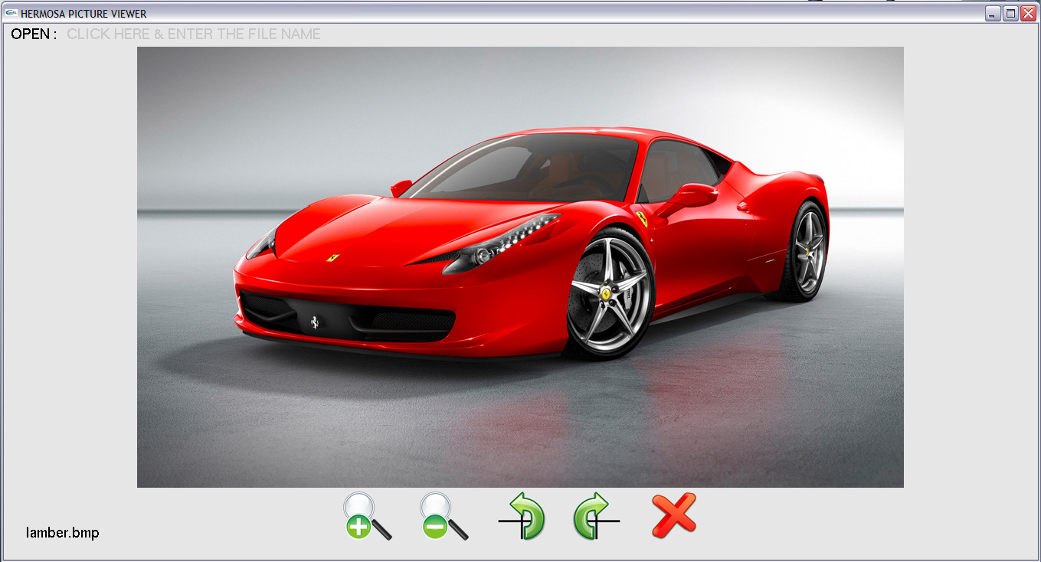

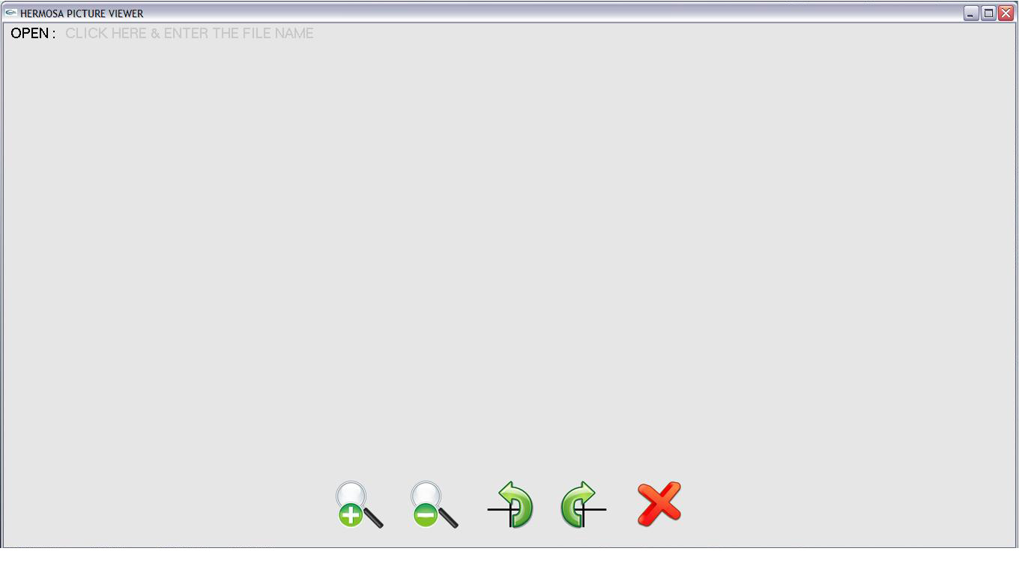

The software is pretty easy to use . Everything is self-explanatory.

Possible Future Improvements:
1 . At this stage ,the user has to type the name of the image file .In future this step can be converted fully into graphical interface i.e. the user will select a file to be opened and it will be viewed in the image viewer
2 . The image will be saved in rotated form when it is rotated in the viewer
3 . At present the software can only view BMP and TGA file. In future it can be modified to view all kind of picture.
4 . In future the software can be used to view images at different modes i.e. sepia,overtone etc.

